Shah Mazhar, Tim Regan

Math 245

09-25-19

**Bikeshare Exploration Model Project 1 Write Up**

Objective/Problem statement:

How someone can efficiently take a bike from three locations with various distance between them? We live in a world where everything moves faster and quicker every day. It is important to keep track of certain system to solve a certain problem. One of the problems might be to keep track of bikes in a time period of a Bikeshare Exploration system. It is important for the management and consumer both to see how many bikes are available for a specific time and a specific location. We like to ask various questions and try to answer it to solve this problem. There are three different locations in our project, location A, B and C. The time duration we are picking in this project is 24 hours for a specific day. So, anyone from the management team might ask the question that how many bikes are available in B at 1 PM? So, the management can do any further steps such as increasing number of bikes based on how popular certain location is or what time of the day the bike gets used the most. These are not our questions to answer for this project, our solution is to give the information of how many bikes available for a certain location for a certain time period. There are also a lot of assumptions in our project to have a simple model that tries to mimic the real world. The assumptions can be rewritten based on collecting real world data, so our model is still viable.

Methodology:

In Mathematical Modeling class, we get introduced to the Bikeshare Exploration model. It consists of 2 locations, Olin and Wellesley, where we keep track of bikes for a certain route for 60 minutes. In our model, we expand our model into 3 different locations (A, B, C), 6 routes, and keeping track of all of the locations at the same time in a 24 hour time period. So, it is really taking the base model into a whole different level. There are plenty of assumptions that were made to make this model work. The first assumption is the numbers of bike in each location, we declare each locations A, B, and C is at 30 bikes at time 0. The second assumption was the time period. The third assumption is the probability of how many bikes that will be in certain location. We made all the probabilities equal to have an unbiased number for each location. Three of these assumptions can be totally different based on real world scenario. These assumptions can be rewritten to answer the questions we are asking. Next we put in the situation if one location rides a bike from one location to another locations. So like if the bike is coming from A and going into C than A loses one bike and C gains one bike, we also did A to B, B to A, B to C, C to B, and C to A. We have to make sure that the end of the results we end up with 90 bikes.

Result:

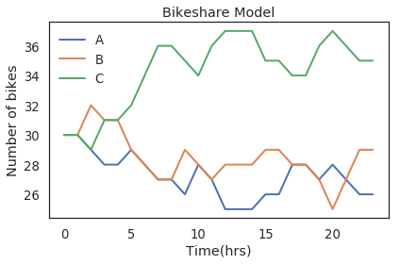

This is the result that answers the questions we were asking. This plot shows three locations that keeps track of the number of bikes in a certain hour of the day. On the X-axis, there are time interval during the day which is a full day or a 24 hour time interval. On the Y-axis, it shows the numbers of bikes. A, B and C are on a line graph that has blue, red and green color respectively which indicates the XY relationship which is the number of bikes for each hour in a day, so we are looking at a 24 hours span between the 3 different locations.

**Analysis:**

The analysis of the bikeshare model was a success. We were able to explain of how many bikes were used and how many bikes were ended up in A, B and C. We started out at each station at 30 and we ended up with a different number of bikes we have A at 26 of bikes, which is 4 less bikes in that area than they started with. In B, we have 35 bikes, which is 5 more bikes than they have. And in C, we have 29 bikes, which is one less bikes than the initial. Since, it depends on the probabilities, it will give us different numbers of bikes each time it was run for different hours of a day. This graph is just showing us the people are using these bikes to go to another borough they use the bikes to go to other boroughs is pretty cool to see for some people they actually use it to go to other boroughs because it's either a good workout for them to use or people can’t keep paying for money to go to school or work and they have to use a bike to get to other places. This model can be much more complex, with the more metrics and the more time looking on each location. Suppose, we can add more locations with different time intervals such as by weeks or months or years. This project taught us the power of programming and how python can solve real world problems such as this.